Client requirements report

Contents

1. Business Domain summary 3

2. Business Requirements Analysis 4

3. System Context Diagram 5

4. Functional Requirements 5

1. Business Domain summary

* This report outlines the client requirements for a medical practice database system. The medical practice offers general medical services by doctors and additional services by specialists like physiotherapists, podiatrists, and optometrists. The system will be used by receptionists to manage patient records, appointments, and pathology test requests.

1. Business Requirements Analysis
   1. Based on the supplied business rules and data, the database for the medical practice must support the following business requirements:
      1. Patient Management:
         1. Store and update personal details of patients (name, address, contact information, Medicare number, etc.).
         2. Ensure all addresses are within Australia.
         3. Support CRUD (Create, Read, Update, Delete) operations, though patient records should never be deleted, only updated.
      2. Appointment Management:
         1. Track both past and future appointments, including patient and practitioner details, appointment date, and start time.
         2. Ensure appointments adhere to business rules, such as practitioner availability and no double-booking.
         3. Support CRUD operations for appointments, including creating, retrieving, updating, and deleting appointments.
      3. Practitioner Management:
         1. Store and update personal details and professional credentials of practitioners.
         2. Ensure each practitioner has a unique AHPRA Medical Registration Number.
         3. Support CRUD operations for practitioners, including setting practitioners as inactive rather than deleting records.
      4. Pathology Test Request Management:
         1. Store details of pathology tests requested for patients, including the type of test, date, and time requested, and the requesting practitioner.
         2. Support CRUD operations for pathology test requests.
         3. Ensure no duplicate test requests for the same patient and time.
2. System Context Diagram

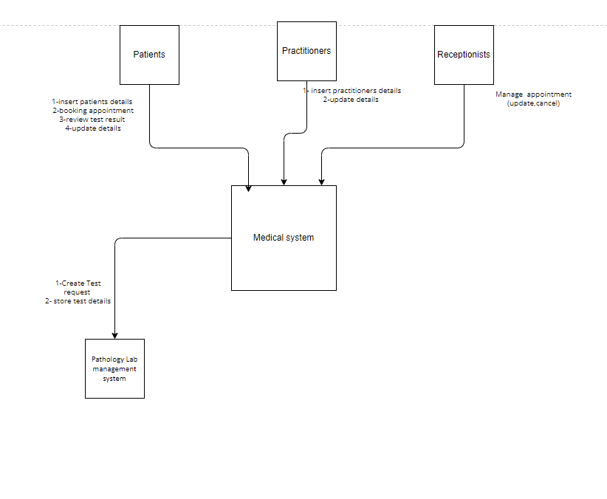

1. Functional Requirements
   1. Patient Management:
      * 1. **Insert Patient Details**: Add new patient records with personal and contact information.
        2. **Retrieve Patient Details**: Fetch existing patient records for review.
        3. **Update Patient Details**: Modify existing patient records to reflect changes in personal or contact information.
   2. Appointment Management:
      * 1. **Create New Appointment**: Schedule new appointments between patients and practitioners, ensuring practitioner availability and no double-booking.
        2. **Retrieve Patient Appointments**: List all appointments for a specific patient.
        3. **Retrieve Practitioner Appointments**: List all appointments for a specific practitioner.
        4. **Retrieve Appointments by Date**: List all appointments for a specific practitioner on a given date.
        5. **Cancel Appointment**: Remove an upcoming appointment from the schedule.
        6. **Update Appointment**: Change the date or time of an existing appointment.
        7. **Delete Appointment**: Remove an appointment from the system (both past and future).
   3. Practitioner Management:
      1. **Insert Practitioner Details**: Add new practitioner records with personal, contact, and professional information.
      2. **Retrieve Practitioner Details**: Fetch existing practitioner records for review.
      3. **Update Practitioner Details:** Modify existing practitioner records to reflect changes in personal, contact, or professional information.
      4. **Set Practitioner Inactive:** Mark a practitioner as inactive if they no longer work at the practice.
   4. Pathology Test Request Management:
      1. **Create Pathology Test Request**: Add new pathology test requests with details of the test, requesting practitioner, and patient.
      2. **Retrieve Pathology Test Requests**: List all pathology tests for a specific patient or by a specific practitioner.
      3. **Delete Pathology Test Request:** Remove a test request from the system.
      4. **List All Pathology Test Requests**: Provide a comprehensive listing of all test requests